**Coalichain ICO ZUZ Token Presale 40 % to 20% Bonus**

Initial Coin Offerings, commonly known as ICO are becoming very famous by the minute. This is because the latest and advanced technology of Blockchain has taken over many sectors of the world and is not just restricted to financial transactions. Event planning companies, health and wellness sectors, politics, food chains and many other industries and setting foot in the blockchain technology because of its amazing features as well as characteristics. Keeping this technology in mind many big companies and mostly startups are investing their time and money in ICO where they raise funds in exchange of their own cryptocurrencies and crypto tokens whose value is likely to increase in the near or long term future.

[**Coalichain**](https://www.coalichain.io/) is a decentralized bridge between the leaders and the citizens that allows them to directly connect with each other and helps in promoting true democracy. Beyond the technical feat and the disruptive effect on conventional communications, the primary focus of **CoaliChain** is to reinforce and enhance freedom of speech and bring democracy back to its pristine splendor. The ideology is the fight against totalitarian rule and dictatorship and we are proud to provide the right infrastructure to enable citizens of the world achieve their noble causes, without prejudice to skin color, origin, and cause.

In order to carry forward activities on **Coalichain**, they use their own cryptocurrency known as the ZUZ Token. The ZUZ token is a crypto-currency that is tendered in the political arena. Its attributes are different from those of a financial crypto-currency. The ZUZ Tokens can be used to conduct local elections. A city forms a partnership with **CoaliChain** to run their local elections for city council members or for a mayoral race. Candidates register. A debate space is configured and budgets are monitored, all within the platform. Similarly there can be general elections as well. In the context of general elections, **CoaliChain’s** versatile platform is first intended for relatively small-scale polls, such as small developing countries lacking the sophisticated infrastructure of European models. Overall, activities like unions, public consultations, referendums, surveys, polls and census are conducted on this platform.

In order to take advantage of all these facilities, ZUZ Tokens needs to be acquired first. **CoaliChain** will give pre-sale and crowdsale participants the opportunity to be pioneers of this initiative through the pre-sale and the crowdsale phases. By collecting as many supporters as possible we will be able to build a more extended platform and to ensure its swift development and adoption worldwide. The presale of the ZUZ Tokens starts from 9TH May 2018 and go on till 11TH June 2018. Then the timeline continues with a crowdsale. Your acquisition of ZUZ tokens will be confirmed as soon as you successfully pass the ID validation and KYC process.

In order to acquire your first batch of ZUZ tokens:

1 - Visit https://Coalichain.io

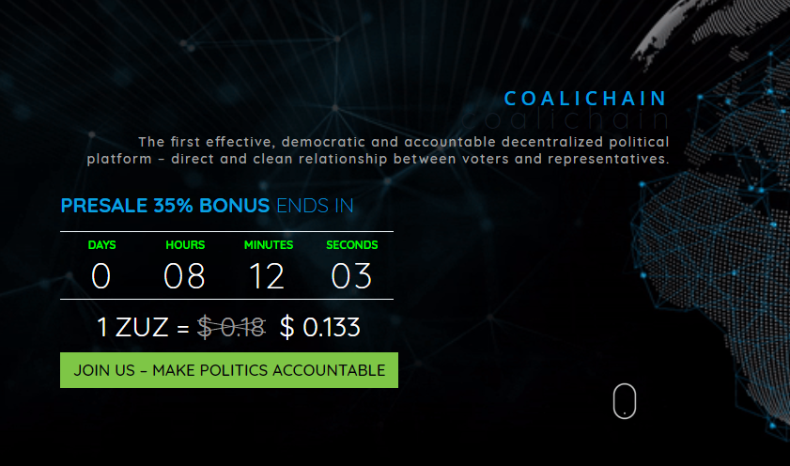

and go to the Token sale section.

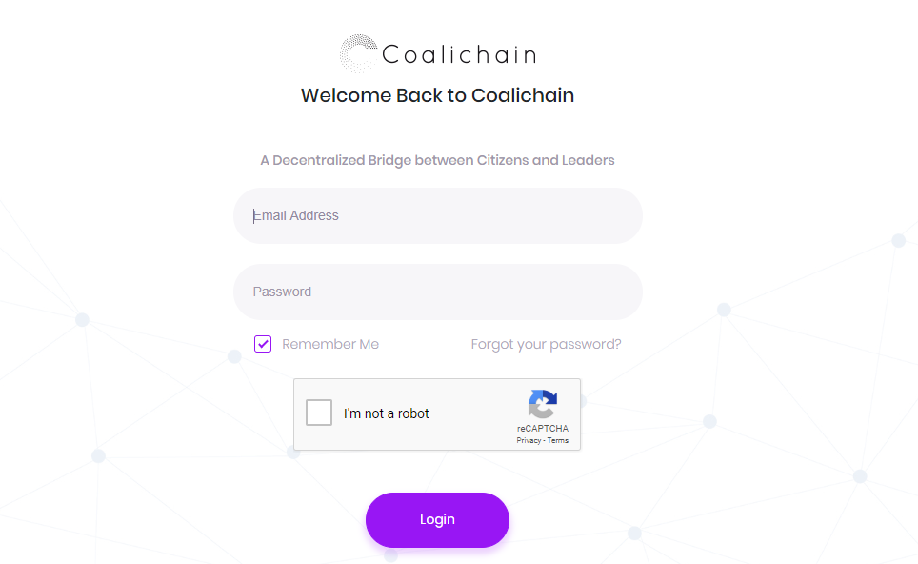

2 - Enter your email address.

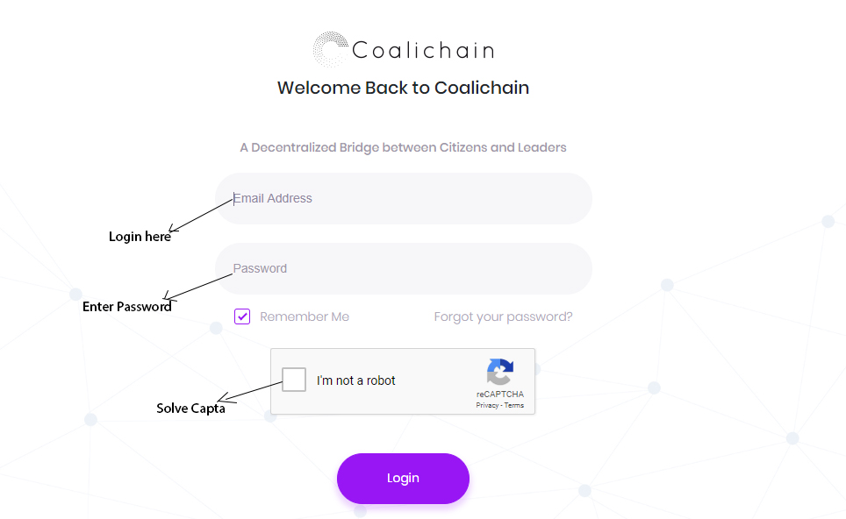

3 - Select the type of currency (BTC, ETH, or LTC, Fiat) you wish to send.

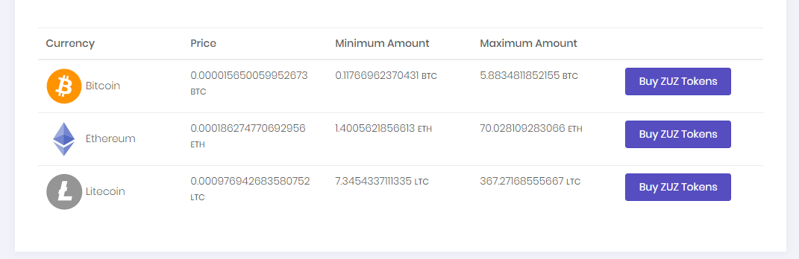

4 - Enter the desired amount of selected currency you intend to send. In the event that you are sending cryptocurrency, please enter the wallet’s public address from which the currency will be sent, or the account’s IBAN from which the fiat money will originate.

5 - Send the amount respectively to CoaliChain’s BTC, ETH wallet or to CoaliChain’s account in case of fiat money. After your payment is confirmed, you will receive the corresponding amount of ZUZ token, specifically: X ZUZ for 1 ETH.